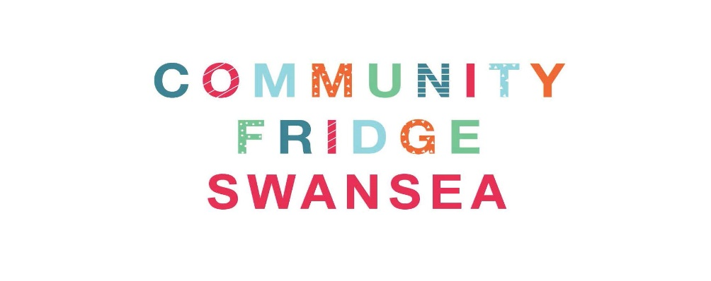
Community Fridge Assistant Role Description
What is the Community Fridge?
Did you know that families in the UK still throw away an average of £810 worth of food per year, while food businesses discard around £3 billion worth? And this is despite more people being more aware of food waste!
The Community Fridge is a great way to reduce this waste, whilst also helping people to access fresh food and tackle food poverty.
Businesses and retailers donate surplus food to the Community Fridge, and we distribute it to members of the community. We never know what will be donated or how much, it will differ week to week.
Since opening to the public in March 2019, the Community Fridge Swansea has helped tackle food poverty and reduce food waste by redistributing, on average, 1 tonne per month. We are very proud of the work that we’ve done so far but recognise that there’s a lot more to do.
The Community Fridge Swansea is run by a small number of staff and a group of dedicated and unpaid volunteers. We work hard during the week to collect food, check the quality of the produce and distribute it to the public.
What is the role?
The role of a Community Fridge Assistant is an exciting and varied one, and may involve a range of duties. These include:
- Ensuring food in the Community Fridge is safe to eat by checking donations and regularly taking stock checks.
- Checking food is stored and packaged correctly.
- Disposing of any food and packaging waste appropriately.
- Ensuring all community Fridge facilities are clean and hygienic.
- Setting up food parcels or moving on packs for people moving into a new home.
- Helping to serve food parcels to Community Fridge Members.
Full training is provided by the organisation, so you’re not expected to join with prior experience or expertise. However, you will need to be physically fit, a good communicator and be able to work independently. You will also need access to a vehicle, in order that you can transport the food.
If you have any other skills, like social media, design or gardening, you may also have the opportunity to participate in some exciting new projects that we are working on.
Aside from this, all we ask is that you bring a positive attitude and enthusiasm for helping the wider community and the reduction of food waste.
What will you gain from volunteering on this project?
As part of this project, you will gain the following:
- Satisfaction of being part of an innovative food sustainability project that helps to save food, feed people and reduce food waste.
- Training and experience in food handling, storage and hygiene protocols.
- Development of communication skills and demonstrable evidence that you can work independently, while also being part of a wider team.
- Expenses for use of your personal vehicle during working hours.
Interested and would like to know more? Please contact us via email at communityfridge@goleudy.org

