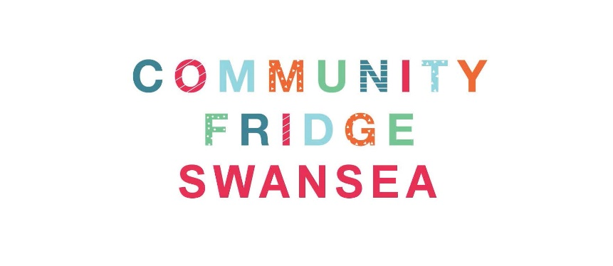
Background information
The Community Fridge Concept
In spite of a growing awareness of food waste, families in the UK still throw away an average of £810 worth of food per year, while food businesses discard around £3 billion worth. The Community Fridge is an increasingly popular means for reducing this waste, while also benefitting communities and tackling food insecurity.
Community Fridges enable retail businesses, restaurants and individual people to share surplus food that is edible and would otherwise go to waste. Under Hubbub’s Community Fridge Network, as at September 2020, there are now over 100 Community Fridges across the United Kingdom.
Community Fridge Swansea
Recognising the potential benefits a community fridge could bring to our organisation and to Swansea, and its natural alignment with our charitable objects and our strategic objectives, a pilot project was set up in late 2018. Our fridge was registered with Hubbub, the umbrella body, and with environmental health and has a five-star food hygiene rating.
The pilot project was an overwhelming success, and, in March 2019, the project opened its doors to the public. Since then, Community Fridge Swansea has redistributed over 14 tonnes of food that would otherwise have gone to waste and has benefitted hundreds of local residents. In addition to our work supporting the community, we’ve also worked in partnership with local agencies, schools and community groups, including youth clubs, charities and support groups, to widen our reach and increase awareness of food waste.
We are registered with food sharing platforms and currently receive donations from 4 major retail organisations, which is where the vast majority of our food comes from. In addition, we receive a small amount of donations of homegrown fruit and vegetables.
The project has a working relationship with Swansea Council’s Food Poverty Team and, in early 2020, was successful in securing funding to enable the project to improve and grow. This included the purchase of a vehicle for transporting donations and holding pop up events.
Covid 19 Response
In mid-March 2020, following advice from Hubbub, we made the difficult decision to close the Community Fridge, in order to mitigate the risk to both staff and customers posed by the Covid-19 pandemic.
After much careful planning and risk assessment, the service was able to open again in late April, with significant changes to the way it operates. Where previously customers had been able to enter the building and help themselves on a self-service model, we successfully moved to providing a window-service, offering a “pack to order” food parcel. This opens once a week and provides a lifeline, not only to those who had used the project previously but also to those who are feeling the impact of the Covid-19 pandemic.
We continue to work with other agencies and are able to meet the needs of different groups through an arrangement whereby we prepare food parcels for families who would find it difficult to reach us, that are collected but their group’s volunteer drivers who deliver it to them.
Most recently, we have launched a new service, the Community Pantry. This is an online ordering service that enables users to place a request for dry store foods, cleaning and hygiene supplies, that are collected at an agreed time.
We are proud of the part our fridge has played in feeding the people of Swansea during the Covid-19 crisis, which required us to rapidly remodel our service to enable it to operate safely and develop new ways of working, to respond to the unique problems presented by lockdown/local restrictions. We have managed to navigate the challenges presented by a disrupted supply of donations and are constantly seeking ways to improve and expand the service for the benefit of the community.

The Future

Against this backdrop, we’re looking for a positive, motivated individual, who can lead and develop this project on its next chapter, so that it can further benefit the community. Our ambition is to continue to develop the service and expand our donation base to enable us to provide free fresh food to even more people.

It’s with this in mind that we’ve created the new Community Fridge Coordinator role. To succeed in this role, you should be flexible and able to adapt to an ever-changing environment, whilst also being able to deliver on long term strategic objectives. To do this, you will need to be a problem solver, have strong relationship building skills and build trust and credibility easily. If you are passionate about providing a great service to our community and believe you have the skills and ideas to ensure fresh food is available for everyone, we would love to hear from you.

For more information, please visit us on social media.

@FridgeSwansea
Swansea_Community_Fridge

